**Examples of Insertion**[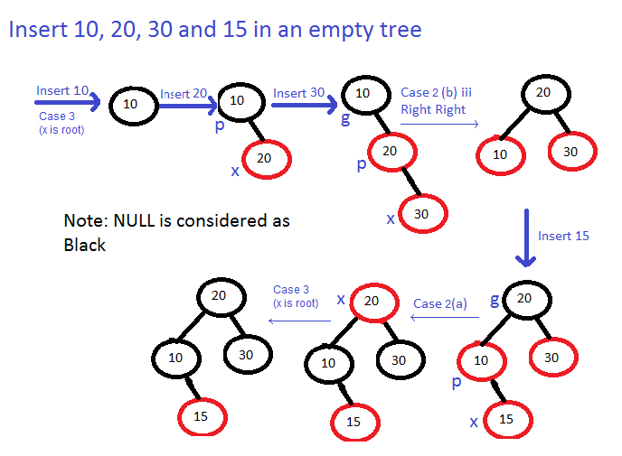](https://media.geeksforgeeks.org/wp-content/cdn-uploads/Examples.png)

**Obtained Output :**

run:

** TOP-DOWN INSERTION IN RED BLACK TREE **

******* TREE NODE REPRESENTATION *******

-------------------------------------------

| DATA | COLOR | LEFT CHILD | RIGHT CHILD |

-------------------------------------------

LEVEL ORDER TRAVERSAL OF TREE

Enter a Node to insert:

**10 y 20 y 30 y 15**

LEVEL ORDER TRAVERSAL OF TREE

-------------------------------------------------------------

***| 10 | B | N | N |***

-------------------------------------------------------------

Do you want to insert more Nodes:[y or n]

Enter a Node to insert:

LEVEL ORDER TRAVERSAL OF TREE

-------------------------------------------------------------

***| 10 | B | N | 20 |***

-------------------------------------------------------------

-------------------------------------------------------------

***| 20 | R | N | N |***

-------------------------------------------------------------

Do you want to insert more Nodes:[y or n]

Enter a Node to insert:

LEVEL ORDER TRAVERSAL OF TREE

-------------------------------------------------------------

***| 20 | B | 10 | 30 |***

-------------------------------------------------------------

-------------------------------------------------------------

***| 10 | R | N | N | | 30 | R | N | N |***

-------------------------------------------------------------

Do you want to insert more Nodes:[y or n]

Enter a Node to insert:

LEVEL ORDER TRAVERSAL OF TREE

-------------------------------------------------------------

***| 20 | B | 10 | 30 |***

-------------------------------------------------------------

-------------------------------------------------------------

***| 10 | B | N | 15 | | 30 | B | N | N |***

-------------------------------------------------------------

-------------------------------------------------------------

***| 15 | R | N | N |***

-------------------------------------------------------------

Do you want to insert more Nodes:[y or n]

**n**

BUILD SUCCESSFUL (total time: 3 minutes 47 seconds

Insert 10, 20, 30, 15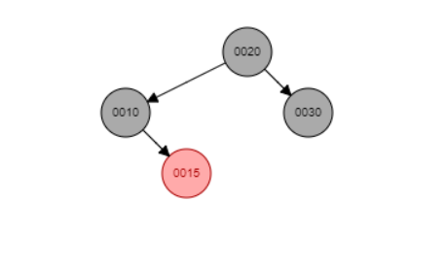Insert 12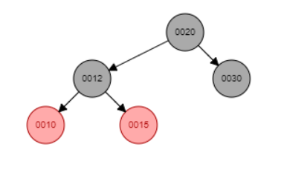

Insert 1, 45